***Amazon sales analysis***

This document contains SQL queries generated to perform ad-hoc analysis of Amazon sales REPORT.

LinkedIn: www.linkedin.com/in/deepanshi-saini-13a8a830a

Email: dpsaini026@gmail.com

use amazon;

select * from [Amazon Sale Report];

**--1. Calculate the total sales (Qty * Price) for each product category.---**

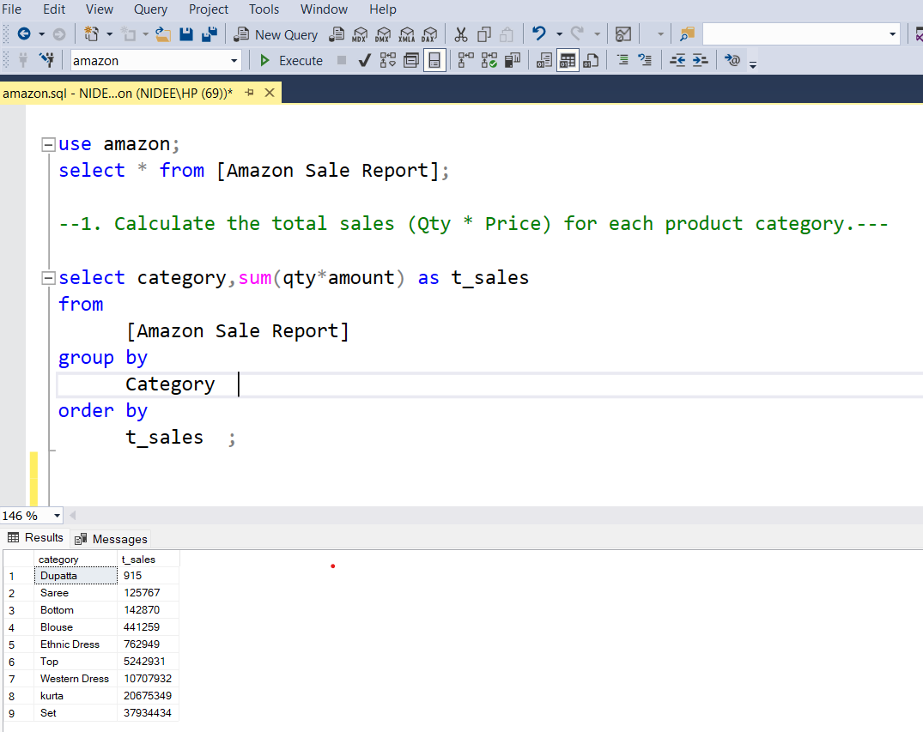

**---2.Count the number of orders for each order status.---**

**---3.Find the top 10 best-selling products (based on quantity sold).---**

**---4.Calculate the average order value (Qty * Price) for each sales channel---**

**---5.Find any duplicate order IDs in the table.---**

**/*6.Segment customers based on their average order value and frequency of purchase. Create three segments: 'High Value Frequent', 'Medium Value Occasional', and**

**'Low Value Infrequent'." */**

**/* 7.For each sales channel, find the top 2 performing product categories based on revenue, and calculate the percentage contribution of each category to the total revenue of that sales**

**channel. */**

**/* 8. Determine which promotion IDs (if any) are associated with the highest average order value and highest quantity sold. Consider only orders fulfilled by Amazon.*/**

**/*9.Calculate the average order value (total value = Qty * Price, assuming a Price column**

**/*10. List the postal codes and countries with more than 15 orders shipped in 2023, from each location*/**

**/*11.Find the product category with the highest average quantity ordered for each size*/**

**/* 12. Find the top 3 ASINs that have the highest number of distinct postal codes they were**

**shipped to*/**

**/*13. calculates the percentage of B2B orders for each sales channel*/**

**/*14. Customers Who Have Ordered from Multiple Sales Channels*/**

**/*15. the Most Popular Size within Each Category */**

